FY Suspense Report

To run FY Suspense Report please do the following:
- Go to HRMS
- From the Menu, select UHS HRMS Payroll→Reports→FY Suspense Report
- Setup or Select a Run Control
- At the Report Parameters Screen, enter the following:
  - As of Date (Last Day of the Previous Accounting Period)
  - Business Unit, HRXXX (i.e. HR730)
  - Select Report Options (Report may be run by Division, College, or Department)
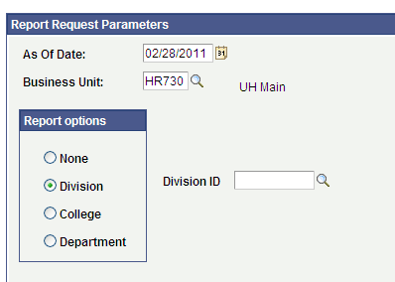

  - If you select Division or College a box will appear with a magnifying glass, you can click on the magnifying glass and select from the list.

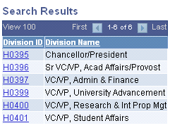
  - If you select the Department option, a window will appear where you can enter the department number; if you click on the plus sign you can enter another department and continue adding departments.
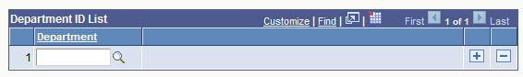

- Review the Suspense Reports
- Make corrections on the Suspense Reports
- Submit Suspense corrections via email or interdepartmental mail to Patricia Howard at phoward@uh.edu or mail code 0902 by the 28th of each month.

